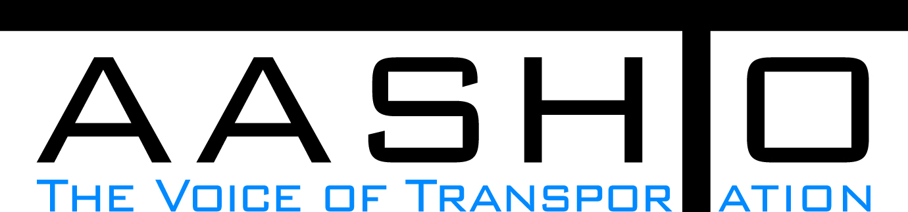Domestic Scan Proposal Form
AASHTO is soliciting topic proposals for a Calendar Year 2014 US Domestic Scan Program (NCHRP Panel 20-68A). Each selected scan topic will be investigated through site visits to three to six locations for approximately a two week period or less (type 1), by webinar, (type 2) peer exchange, or (type 3) conducted by a group of eight to 12 transportation professionals with expertise in the selected topic area. Proposed topics should meet the following criteria:
- Address an important and timely need for information by transportation agencies;
- Are of interest to a broad national spectrum of people and agencies;
- Are complex and also “hands-on,” meaning they lend themselves particularly well to exploration through on-site visits; and
- Are sufficiently focused that the tour participants are able to investigate and understand key issues in the limited time available on the tour.

Before submitting your proposal it is highly recommended that you read What Makes a Good Scan Topic Proposal http://www.domesticscan.org/what-makes-a-good-scan-topic-proposal
This form is designed to collect the full length of your proposal. Sections requiring essays have unlimited space for you to use. Contact information has some limited text. Use your TAB→ key to advance to the area where you need to complete information.
Proposals should be returned no later than OCTOBER 15, 2013.
IMPORTANT NOTE on How to save your document: LastNameFirst Initial, underscore_Organization Acronym _CY2014.
Saved Document Name Example: VitaleM_AASHTO_CY2014
If you have more than one, add a number after first initial: VitaleM1_AASHTO_CY2014

Domestic Scan Proposal Contact Information
Name | LENI OMAN | Address | PO Box 47372, Olympia, WA 98504-7372
Title | Director, Office Of Research & Library Services | E-mail | OmanL@wsdot.wa.gov
Member Department | Washington State DOT | Telephone number | 360-705-7974
AASHTO Committee | SCOFA | Date of submission | 10/15/2013

Title of Proposed Scan: Factors for duccess in developing and implementing revenue solutions

Problem Statement (What topic is to be examined? What drives the need for the scan? Why now?)
State departments of transportation (DOTs) operate in an environment where the traditional institutional framework for funding transportation improvements is increasingly in flux. Acknowledging the growing consensus that federal support for transportation infrastructure investment will continue to ebb, many state governments – along with local jurisdictions and independent transportation authorities – are examining and actively pursuing measures they can use to generate the resources needed to maintain and improve transportation systems. Indeed, 2013 has seen a flurry of state house activity preparing for an era of continued shrinkage of federal transportation funding and expanded importance of state self-sufficiency. State-level revenue solutions both considered and enacted include the application of mileage based user fees; increases in traditional motor fuels taxes and automobile excise fees, road-user tolls, and also general sales taxes; indexing of existing taxes to inflation; changing the mix of state revenue sources used to pay for transportation; as well as enabling voluntary regional and sub-state taxes for transportation. In some cases, states have opted to levy a sales tax on motor fuel sales in lieu of the traditional per-gallon motor fuel tax. At this important juncture, this scan will examine how state DOTs can be effective partners in wider efforts to develop and implement revenue solutions to increasingly stark state transportation needs. The research proposes to learn from the most current and productive state-level initiatives to boost transportation resources, focusing specifically on the role that state DOTs have played in facilitating acknowledged successes and that they may play in future efforts elsewhere.

Scan Scope (What specific subject areas are to be examined? Which cities and states might be visited? Which agencies/organizations (including specific departments or types of staff if applicable)?
This scan would focus on the informational, organizational, and political considerations to be made by state DOTs when participating in wider discussions and initiatives – at state, sub-state, or even multi-state levels – to increase transportation revenues. The scan will look to the experiences of Departments that have recently participated in such initiatives, both successfully and unsuccessfully. It would include DOT personnel with insights into informational, organizational, and political issues at hand, including Chief Financial Officers / Finance Staff; Legislative / Governmental Affairs staff; Programming, Budgets, Policy staff; and Public Affairs / Communication staff. The scan will focus on the types of revenue measures considered and the factors that informed decisions to pursue the particular options chosen. The research will investigate the genesis of the new revenue measure (whether originating within the DOT, the legislature, or a legislative commission tasked to examine transportation finance issues) and the path to its enactment. Was there broad based support for the revenue initiative, or did backers of the initiative have to build a coalition of supporters. If so, what efforts were undertaken at key points to build support for the measure? Candidate state departments of transportation include: Virginia; Oregon; Georgia; Maryland, Iowa, and Washington State.

Anticipated Scan Results (What key information is to be gained? What information is to be shared after the scan? Who would the audience be for this information?)
The scan will identify and discuss how state DOTs can engage productively in efforts to improve state-level revenues for transportation. As more states confront this issue, internal knowledge accrued by peer departments involved in similar efforts is increasingly important. When a state DOT faces the opportunity – or necessity – to engage in such discussions, strategic questions present themselves: With what constituencies must the DOT be ready to engage? What new organizational and institutional relationships need nurturing? What informational and analytical resources can DOTs bring to the table? How can the department contribute the most value in efforts to identify and realize revenue solutions? What messages resonate with elected officials and the public at large when making the case for increasing local transportation revenues? Further, what pitfalls must DOTs avoid in navigating the political terrain of such discussions?
This scan will focus on these questions, highlighting the productive ideas behind state efforts to significantly improve their ability to fund needed transportation improvements. Drawing on the experiences of states leading the wave of experimentation in this domain, the research will explore what states are doing today to develop new -- and revitalize conventional -- revenue sources. It will emphasize how state DOTs can be more effective partners with state executive, legislative, and even sub state or multi-state actors to gain support for raising new transportation revenues by engaging with broad coalitions of legislators, business leaders and citizens.

Benefits Expected (Including potential impacts on current technology or procedures)
The issue of state transportation revenues is undeniably important to today’s DOTs. They face stagnant federal funding levels, Congressional unwillingness to fund long-term infrastructure needs, and – in many cases – a history of similar reluctance in their own state houses. The research will provide frank discussions of political terrain to be encountered when developing new and enhancing existing state sources for transportation revenue. It will provide a broader understanding of potential pitfalls that may thwart such efforts and of the productive strategies state DOTs can adopt to aid efforts to increase state revenues for transportation.
Person to person knowledge sharing is essential in answering these kinds of questions, as the political, organizational, and informational dynamics and nuances are information not be readily captured in standard legislative or policy reports. The research will illuminate the internal workings behind successful (and unsuccessful) legislative attempts to raise transportation revenues, offering guidance to state agencies as they navigate the complexities of a funding landscape in great transition.

